1. **The mass and mass moment of inertia**

|  |  |  |  |  |
| --- | --- | --- | --- | --- |
|  | Item | uniform load(kgf/m2) | area(m2) | weight(kgf) |
| RF | Averaged concrete slab weight | 280 | 1188 | 332640 |
| Ceiling, air-condition piping and floor finishing | 150 | 1188 | 178200 |
| Exterior walls(vertical surface) | 120 | 262.2 | 31464 |
| Parapet in the roof | 120 | 193.2 | 23184 |
| Average weight of steel frame | 80 | 1188 | 95040 |
| Mechanical equipment and roof water tank weighs |  |  | 81000 |
| Σ | | | 741528 |
| 3F | Averaged concrete slab weight | 280 | 1188 | 332640 |
| Ceiling, air-condition piping and floor finishing | 150 | 1188 | 178200 |
| Exterior walls(vertical surface) | 120 | 524.4 | 62928 |
| Partition walls | 100 | 1188 | 118800 |
| Average weight of steel frame | 80 | 1188 | 95040 |
| Σ | | | 787608 |
| 2F | Averaged concrete slab weight | 280 | 1188 | 332640 |
| Ceiling, air-condition piping and floor finishing | 150 | 1188 | 178200 |
| Exterior walls(vertical surface) | 120 | 524.4 | 62928 |
| Partition walls | 100 | 1188 | 118800 |
| Average weight of steel frame | 80 | 1188 | 95040 |
| Σ | | | 787608 |
| 1F | Averaged concrete slab weight | 280 | 1188 | 332640 |
| Ceiling, air-condition piping and floor finishing | 150 | 1188 | 178200 |
| Exterior walls(vertical surface) | 120 | 524.4 | 62928 |
| Partition walls | 100 | 1188 | 118800 |
| Average weight of steel frame | 80 | 1188 | 95040 |
| Σ | | | 787608 |
| Total weight(kgf) | | | | 3104352 |

|  |  |  |  |  |  |  |  |
| --- | --- | --- | --- | --- | --- | --- | --- |
| **Story** | **Lx(m)** | **Ly(m)** | **Deck Thickness(m)** | **Mass(kgf)** | **Mass Moment of Inertia in x dir. (kgf-m2)** | **Mass Moment of Inertia in y dir. (kgf-m2)** | **Mass Moment of Inertia in z dir. (kgf-m2)** |
| **RF** | 36 | 33 | 0.15 | 741528 | 67295056.37 | 80086414.37 | 147378690 |
| **4F** | 36 | 33 | 0.15 | 787608 | 71476902.77 | 85063140.77 | 156537090 |
| **3F** | 36 | 33 | 0.15 | 787608 | 71476902.77 | 85063140.77 | 156537090 |
| **2F** | 36 | 33 | 0.15 | 787608 | 71476902.77 | 85063140.77 | 156537090 |

1. **設計流程**
2. 利用ETABS建立模型，並選用A572 GR50做為鋼材材料和使用Auto Select List繪製桿件。
3. 輸入x向和y向各樓層地震力。
4. 選擇Deformation Control Element

MRF：檢核強柱弱粱

EBF：檢核Link Sections

BRBF：檢核Brace Sections

1. **Design MRF frame in the x direction**

建模設定:

1. 繪製構架
2. 設定規範地震力
3. 添加lump mass並設定diaphragms

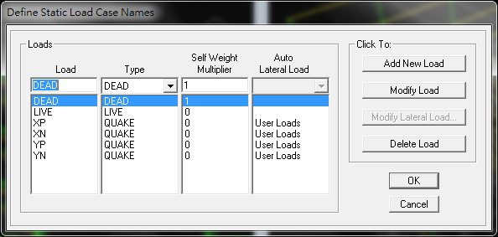 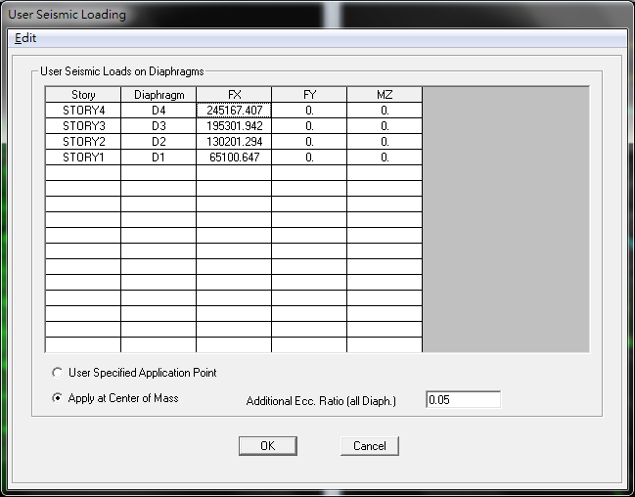

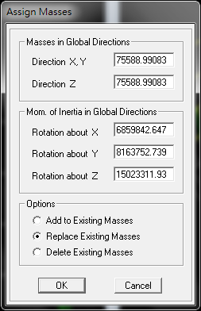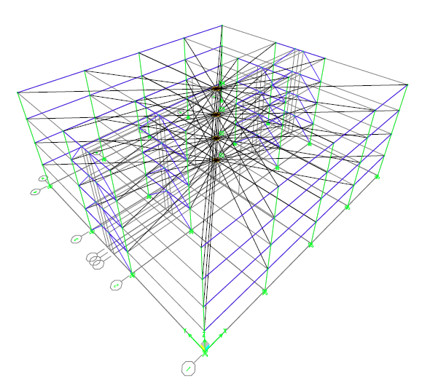

**MRF設計**

1. 由柱剪力估算出所需柱尺寸大小
2. 須滿足強柱弱梁要求
3. Story drift小於0.005 radian

**設計結果:**

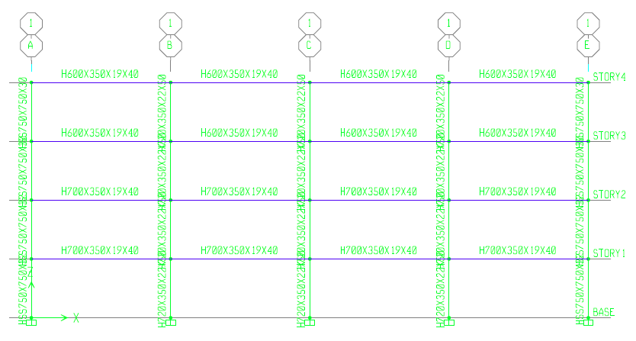

|  |  |  |  |
| --- | --- | --- | --- |
| Story | Beam | Wide Flange Column | Box Column at corner |
| RF | H600×350×19×40 | H720×350×22×50 | HSS750×750×30 |
| 4F | H600×350×19×40 | H720×350×22×50 | HSS750×750×30 |
| 3F | H700×350×19×40 | H720×350×22×50 | HSS750×750×32 |
| 2F | H700×350×19×40 | H720×350×22×50 | HSS750×750×32 |

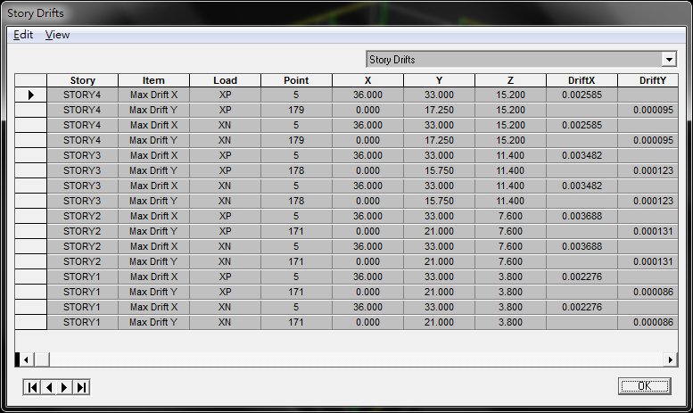

1. **Design EBF**

步驟:

1. 以規範地震力求出Link的剪力需求

利用力平衡求出斜撐、柱、連桿上的需求力

#Link長取1.5m

|  |  |  |  |  |  |  |
| --- | --- | --- | --- | --- | --- | --- |
| **STORY** | **Lateral force(kgf)** | **cumulative lateral force(kgf)** | **Lateral force (kgf)** | **Brace force(kgf)** | **Column force(kgf)** | **shear demand(kgf)** |
| RF | 284911.3416 | 284911.3416 | 71227.83541 | 50702.56848 | 6014.79499 | 30073.97495 |
| 3F | 226962.2172 | 511873.5588 | 127968.3897 | 91092.5624 | 10806.21958 | 54031.09788 |
| 2F | 151308.1448 | 663181.7036 | 165795.4259 | 118019.225 | 14000.50263 | 70002.51316 |
| 1F | 75654.07239 | 738835.776 | 184708.944 | 131482.5563 | 15597.64416 | 77988.2208 |

1. 設計link
2. 設計柱及斜撐

**設計結果:**

Link:

|  |  |  |  |  |  |  |
| --- | --- | --- | --- | --- | --- | --- |
| **Story** | **selected section** | **Vp (kgf)** | **Mp (kgf-m)** | **link type** | **Vn(kgf)** | **DCR** |
| RF | H442X400X22X36 | 170940 | 230977.25 | **shear** | 170940 | **0.195** |
| 3F | H442X400X22X36 | 170940 | 230977.25 | **shear** | 170940 | **0.351** |
| 2F | H450X400X25X40 | 194250 | 259546.875 | **shear** | 194250 | **0.400** |
| 1F | H450X400X25X40 | 194250 | 259546.875 | **shear** | 194250 | **0.446** |

Brace:

|  |  |  |  |
| --- | --- | --- | --- |
| **Brace Demand** | | | |
| **Story** | **Vult (kgf)** | **Mult (kgf-m)** | **Pult (kgf)** |
| RF | 235042.5 | 176281.88 | 363242.76 |
| 3F | 235042.5 | 176281.88 | 363242.76 |
| 2F | 267093.75 | 200320.31 | 412775.86 |
| 1F | 267093.75 | 200320.31 | 412775.86 |

|  |  |  |  |  |  |
| --- | --- | --- | --- | --- | --- |
| **Brace Design Check** | | | | | |
| **Story** | **selected section** | **r(m)** | **λ** | **Pn (kgf)** | **DCR** |
| RF | HSS300X300X16 | 0.1161 | 0.6063 | 545352.5091 | **0.784** |
| 3F | HSS300X300X16 | 0.1161 | 0.6063 | 545352.5091 | **0.784** |
| 2F | HSS300X300X16 | 0.1161 | 0.6063 | 545352.5091 | **0.890** |
| 1F | HSS300X300X16 | 0.1161 | 0.6063 | 545352.5091 | **0.890** |

Outside Beam:

|  |  |  |  |
| --- | --- | --- | --- |
| **Outside Beam Demand** | | | |
| **Story** | **Vult (kgf)** | **Mult (kgf-m)** | **Pult (kgf)** |
| RF | 206837.4 | 155128.05 | 224527.44 |
| 3F | 206837.4 | 155128.05 | 224527.44 |
| 2F | 235042.5 | 176281.88 | 255144.82 |
| 1F | 235042.5 | 176281.88 | 255144.82 |

|  |  |  |  |  |  |  |  |  |
| --- | --- | --- | --- | --- | --- | --- | --- | --- |
| **Outside Beam Design Check** | | | | | | | | |
| **Story** | **selected section** | **r(m)** | **λ** | **Pn (kgf)** | **Mn (kgf-m)** | **DCR of P** | **DCR of M** | **DCR** |
| **RF** | H442X400X22X36 | 0.102 | 0.4847 | 1170410.621 | 230965 | 0.205 | 0.603 | **0.808** |
| **3F** | H442X400X22X36 | 0.102 | 0.4847 | 1170410.621 | 230965 | 0.205 | 0.603 | **0.808** |
| **2F** | H450X400X25X40 | 0.1018 | 0.4857 | 1309464.635 | 259560 | 0.208 | 0.610 | **0.818** |
| **1F** | H450X400X25X40 | 0.1018 | 0.4857 | 1309464.635 | 259560 | 0.208 | 0.610 | **0.818** |

Column:

|  |  |  |
| --- | --- | --- |
| **Column Demand** | | |
| **Story** | **Vult (kgf)** | **Pult (kgf)** |
| RF | 206837.4 | -20683.74 |
| 3F | 206837.4 | 186153.66 |
| 2F | 235042.5 | 390170.55 |
| 1F | 235042.5 | 625213.05 |

|  |  |  |  |  |  |
| --- | --- | --- | --- | --- | --- |
| **Column Design Check** | | | | | |
| **Story** | **selected section** | **r(m)** | **λ** | **Pn (kgf)** | **DCR** |
| **RF** | H390X300X10X16 | 0.0739 | 0.6780 | 381067.4287 | **-0.064** |
| **3F** | H390X300X10X16 | 0.0739 | 0.6780 | 381067.4287 | **0.575** |
| **2F** | H600X400X19X40 | 0.101 | 0.4961 | 1322831.284 | **0.347** |
| **1F** | H600X400X19X40 | 0.101 | 0.4961 | 1322831.284 | **0.556** |

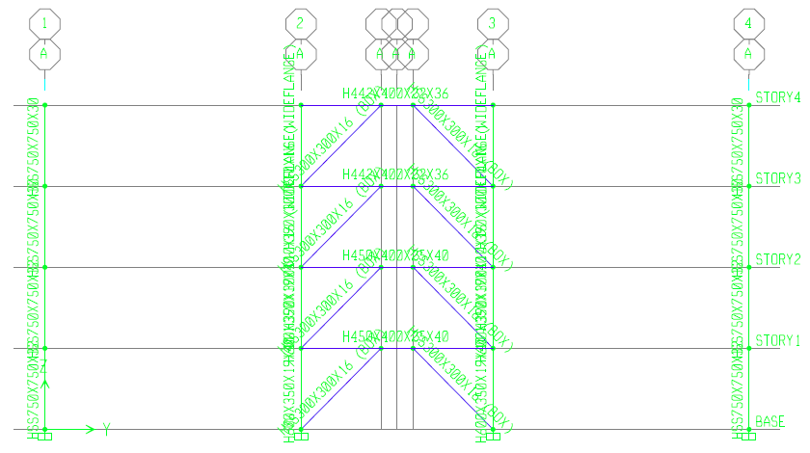

|  |  |  |  |
| --- | --- | --- | --- |
| **Story** | **Beam and Link** | **Wide Flange Column** | **Brace** |
| **RF** | H442×400×22×36 | H390×300×10×16 | HSS300×300×16 |
| **4F** | H442×400×22×36 | H390×300×10×16 | HSS300×300×16 |
| **3F** | H450×400×25×40 | H600×350×19×40 | HSS300×300×16 |
| **2F** | H450×400×25×40 | H600×350×19×40 | HSS300×300×16 |

1. **Design BRBF**
2. 以規範地震力求出Brace force

|  |  |  |  |  |
| --- | --- | --- | --- | --- |
| **BRB demand** | | | | |
| **Story** | **Lateral force (kgf)** | **Cumulative lateral force (kgf)** | **Lateral force on BRBF(kgf)** | **Brace force(kgf)** |
| **RF** | 284911.3416 | 284911.3416 | 71227.83541 | 46613.2503 |
| **3F** | 226962.2172 | 511873.5588 | 127968.3897 | 83745.66692 |
| **2F** | 151308.1448 | 663181.7036 | 165795.4259 | 108500.6113 |
| **1F** | 75654.07239 | 738835.776 | 184708.944 | 120878.0835 |

(2)設計Brace

(3)設計柱及梁

**設計結果:**

Brace:

|  |  |  |  |  |  |
| --- | --- | --- | --- | --- | --- |
| **BRB Design** | | | | | |
| **Story** | **Core section (mm)** | | **Ac (m2)** | **0.9FyAc (kgf)** | **DCR** |
| RF | 55 | 55 | 0.003025 | 95287.5 | 0.4892 |
| 3F | 55 | 55 | 0.003025 | 95287.5 | 0.8789 |
| 2F | 65 | 65 | 0.004225 | 133087.5 | 0.8153 |
| 1F | 65 | 65 | 0.004225 | 133087.5 | 0.9083 |
| **Story** | **Brace length (m)** | **Tmax(kgf)** | **Cmax(kgf)** | **Keff (kgf/m)** | **Eeff** |
| RF | 5.889821729 | 151401.25 | 166541.375 | 10470904.95 | 20387359837 |
| 3F | 5.889821729 | 151401.25 | 166541.375 | 10470904.95 | 20387359837 |
| 2F | 5.889821729 | 211461.25 | 232607.375 | 14624652.37 | 20387359837 |
| 1F | 5.889821729 | 211461.25 | 232607.375 | 14624652.37 | 20387359837 |

Beam:

|  |  |  |  |  |  |
| --- | --- | --- | --- | --- | --- |
| **Beam Demand** | | | | | |
| **Story** | **Tmax (kgf)** | **Cmax (kgf)** | **Maximum Axial Force** | **V (kgf)** | **Mmax (kgf-m)** |
| RF | 151401.25 | 166541.375 | 121458.84 | 4884.06 | 21978.26602 |
| 3F | 151401.25 | 166541.375 | 121458.84 | 4884.06 | 21978.26602 |
| 2F | 211461.25 | 232607.375 | 169640.86 | 6821.54 | 30696.917 |
| 1F | 211461.25 | 232607.375 | 169640.86 | 6821.54 | 30696.917 |

|  |  |  |  |  |  |
| --- | --- | --- | --- | --- | --- |
| **Beam design** | | | | | |
| **Story** | **Selected Section** | **r(m)** | **λ** | **Pn(kgf)** | **Mn(kgf-m)** |
| **RF** | H390×300×10×16 | 0.0739 | 0.8029 | 352654.0165 | 74060 |
| **3F** | H390×300×10×16 | 0.0739 | 0.8029 | 352654.0165 | 74060 |
| **2F** | H390×300×10×16 | 0.0739 | 0.8029 | 352654.0165 | 74060 |
| **1F** | H390×300×10×16 | 0.0739 | 0.8029 | 352654.0165 | 74060 |

|  |  |  |  |  |  |
| --- | --- | --- | --- | --- | --- |
| **Beam design** | | | | | |
| **Story** | **DCR of Pc** | **DCR of Pt** | **DCR of M** | **DCR (tension)** | **DCR (compression)** |
| **RF** | 0.4052 | 0.2921 | 0.26645 | 0.55856 | 0.67165 |
| **3F** | 0.4052 | 0.2921 | 0.26645 | 0.55856 | 0.67165 |
| **2F** | 0.5659 | 0.4080 | 0.37215 | 0.78014 | 0.93808 |
| **1F** | 0.5659 | 0.4080 | 0.37215 | 0.78014 | 0.93808 |

Column:

|  |  |  |  |  |
| --- | --- | --- | --- | --- |
| **Story** | **Tmax (kgf)** | **Cmax (kgf)** | **Maximum compression force in column (kgf)** | **Maximum tension force in column (kgf)** |
| **RF** | 151401.25 | 166541.375 | 94579.61 | 104037.57 |
| **3F** | 151401.25 | 166541.375 | 198617.18 | 198617.18 |
| **2F** | 211461.25 | 232607.375 | 190957.02 | 206277.35 |
| **1F** | 211461.25 | 232607.375 | 351820.52 | 367140.85 |

|  |  |  |  |  |  |  |
| --- | --- | --- | --- | --- | --- | --- |
| **Story** | **selected section** | **r(m)** | **λ** | **Pn (kgf)** | **DCR (tension)** | **DCR (compression)** |
| **RF** | H390×300×10×16 | 0.0739 | 0.6780 | 381067.4287 | 0.2920 | 0.2502 |
| **3F** | H390×300×10×16 | 0.0739 | 0.6780 | 381067.4287 | 0.6132 | 0.4777 |
| **2F** | H390×300×10×16 | 0.102 | 0.4912 | 1167321.511 | 0.1925 | 0.1775 |
| **1F** | H390×300×10×16 | 0.102 | 0.4912 | 1167321.511 | 0.3546 | 0.3159 |

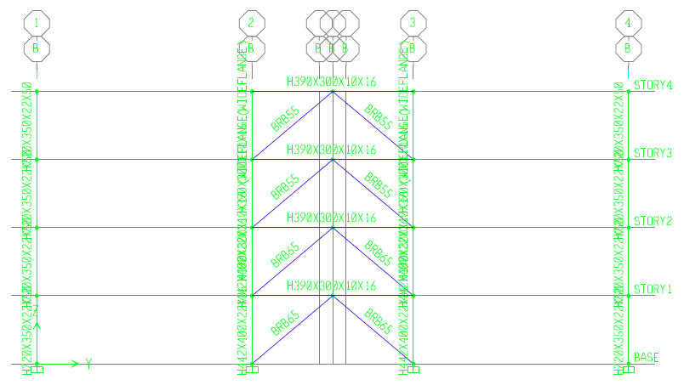

|  |  |  |  |
| --- | --- | --- | --- |
| **Story** | **Beam** | **Wide Flange Column** | **Brace** |
| **RF** | H390×300×10×16 | H390×300×10×16 | Rec55×55 |
| **4F** | H390×300×10×16 | H390×300×10×16 | Rec55×55 |
| **3F** | H390×300×10×16 | H442×400×22×36 | Rec65×65 |
| **2F** | H390×300×10×16 | H442×400×22×36 | Rec65×65 |

1. **Check Structural Periods & Story Drifts**

**Structural Periods:**

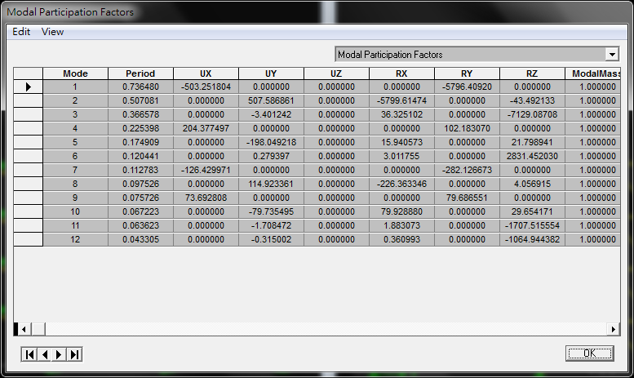

|  |  |  |  |
| --- | --- | --- | --- |
|  | **TETABS(sec)** | **Texperience(sec)** | **1.4Texperience(sec)** |
| **Longitudinal direction** | 0.7365 | 0.6543 | 0.91602 |
| **Transverse direction** | 0.5071 | 0.5389 | 0.75446 |

**Story Drift:**

**Longitudinal direction**

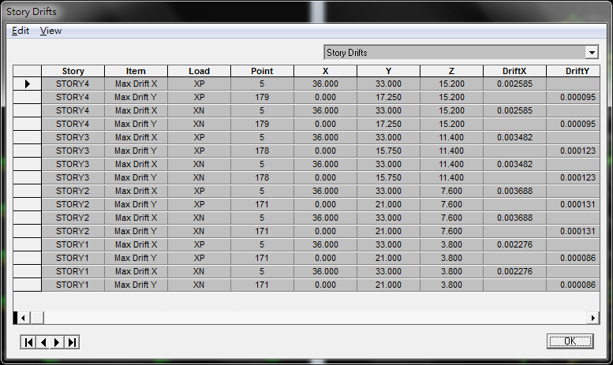

**Transverse direction**

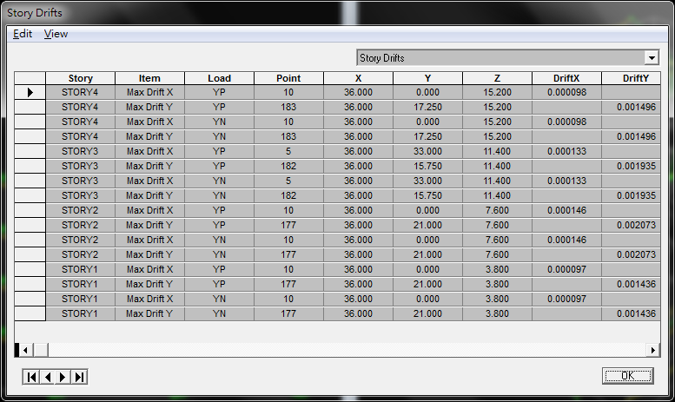

|  |  |  |
| --- | --- | --- |
| Story | **Longitudinal direction** | **Transverse direction** |
| RF | 0.002585 | 0.001496 |
| 4F | 0.003482 | 0.001935 |
| 3F | 0.003688 | 0.002073 |
| 2F | 0.002276 | 0.001436 |

**Vibration period of structure:**

|  |  |  |
| --- | --- | --- |
| **Mode** | **Period (sec)** |  |
| **1** | 0.7365 |  |
| **2** | 0.5071 |  |
| **3** | 0.3666 |  |
| **4** | 0.2254 |  |
| **5** | 0.1749 |  |
| **6** | 0.1204 |  |

**Code Base Shear:**

|  |  |  |
| --- | --- | --- |
|  | Longitudinal direction | Transverse direction |
|  | MRF(T = 0.085H3/4) | BRBF, EBF(T = 0.07H3/4) |
|  | 0.1948 | 0.2338 |
| $${\left(\frac{S_{aM}}{F_{uM}}\right)}_{m}$$ | 0.1751 | 0.2125 |
| $$V/W=\frac{S_{aD}I}{1.4α_{y}F_{u}}$$ | 0.1739 | 0.2088 |
| $$V^{*}/W=\frac{IF_{u}}{4.2α_{y}}(\frac{S_{aD}}{F_{u}})_{m}$$ | 0.2048 | 0.2380 |
| $$V^{M}/W=\frac{I}{1.4α_{y}}(\frac{S_{aM}}{F_{uM}})_{m}$$ | 0.1563 | 0.1897 |
| $$V_{Design}$$ | 635.77tf | 738.84tf |

**Seismic Lateral Forces:**

|  |  |  |  |  |
| --- | --- | --- | --- | --- |
| **In the longitudinal direction** | | | | |
| **VDesign(tf)** | | | 635.77 | |
| **Story** | **Story weight(kgf)** | **Story height(m)** | **Wxhx(kgf-m)** | **Lateral force(tf)** |
| **RF** | 741528 | 15.2 | 11271225.6 | 245.17 |
| **3F** | 787608 | 11.4 | 8978731.2 | 195.30 |
| **2F** | 787608 | 7.6 | 5985820.8 | 130.20 |
| **1F** | 787608 | 3.8 | 2992910.4 | 65.10 |
| **Total** | | | 29228688 | 635.77 |

|  |  |  |  |  |
| --- | --- | --- | --- | --- |
| **In the transverse direction** | | | | |
| **V(tf)** | | | 738.84 | |
| **Story** | **Story weight(kgf)** | **Story height(m)** | **Wxhx(kgf-m)** | **Lateral force(tf)** |
| **RF** | 741528 | 15.2 | 11271225.6 | 284.91 |
| **3F** | 787608 | 11.4 | 8978731.2 | 226.96 |
| **2F** | 787608 | 7.6 | 5985820.8 | 151.31 |
| **1F** | 787608 | 3.8 | 2992910.4 | 75.65 |
| **Total** | | | 29228688 | 738.84 |

**Average steel weight:**

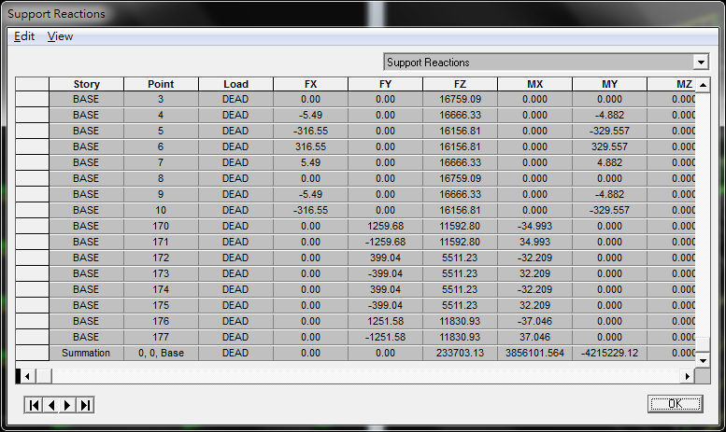

**Total**

**Average steel weight=233703.13/(36*33*4)=49.18 kgf/m2 per floor**